1. Install and run Git for windows (should be already installed)

1. Create a local git repository

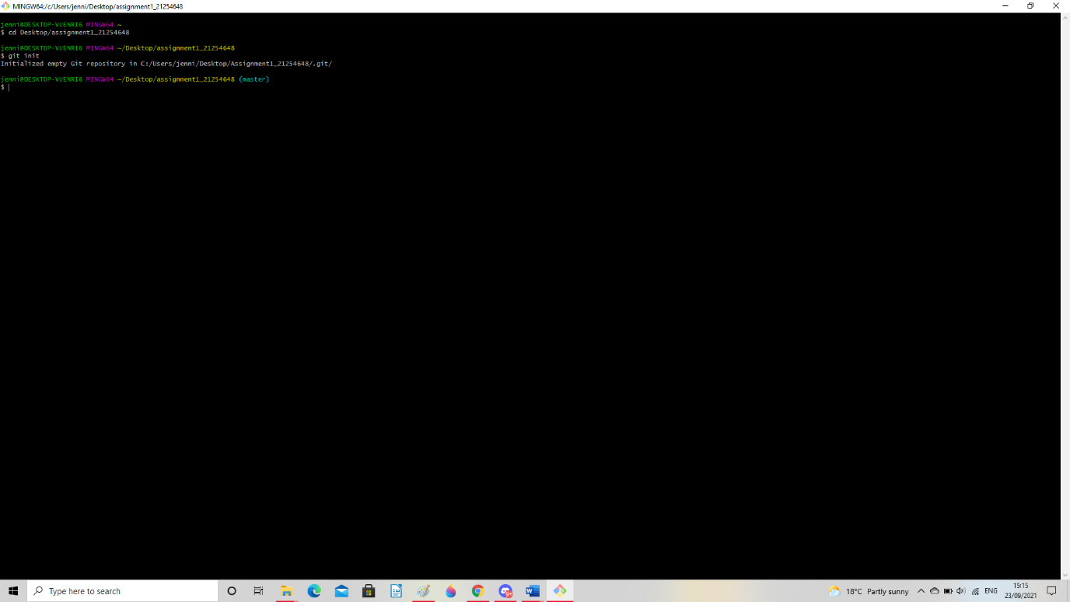

1. initialize git repository

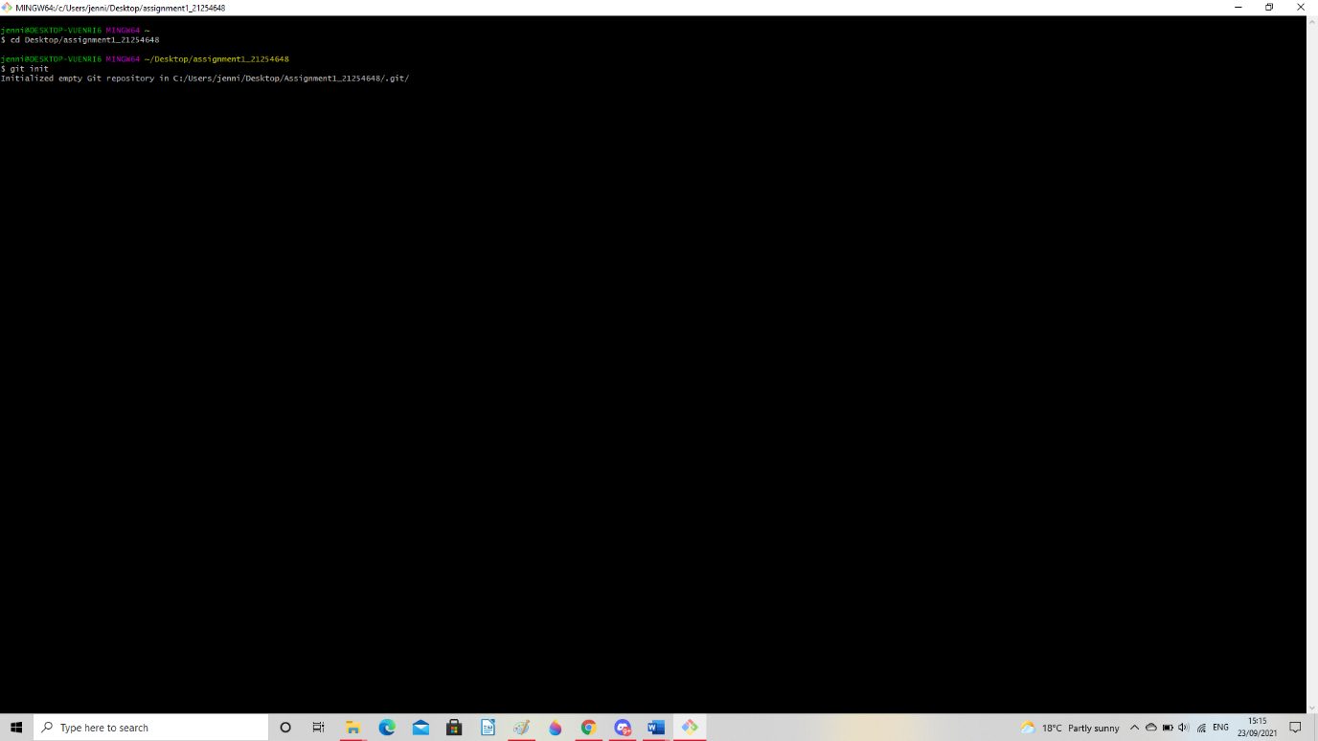

1. Add User information

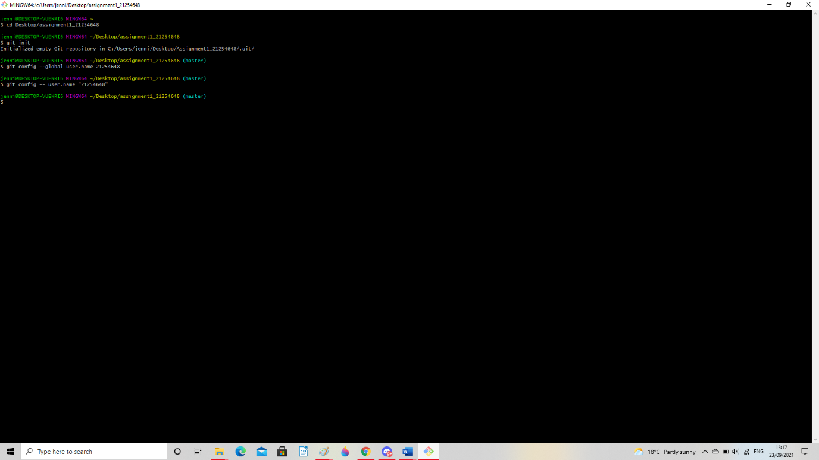

1. Add a new file to the repo

1. Add a file to the staging environment

1. Create a commit

1. Connect with GitHub

